IEEE-NANOMED 2026
Registration (Step by step guidelines)

Step 1: fill in attendees info
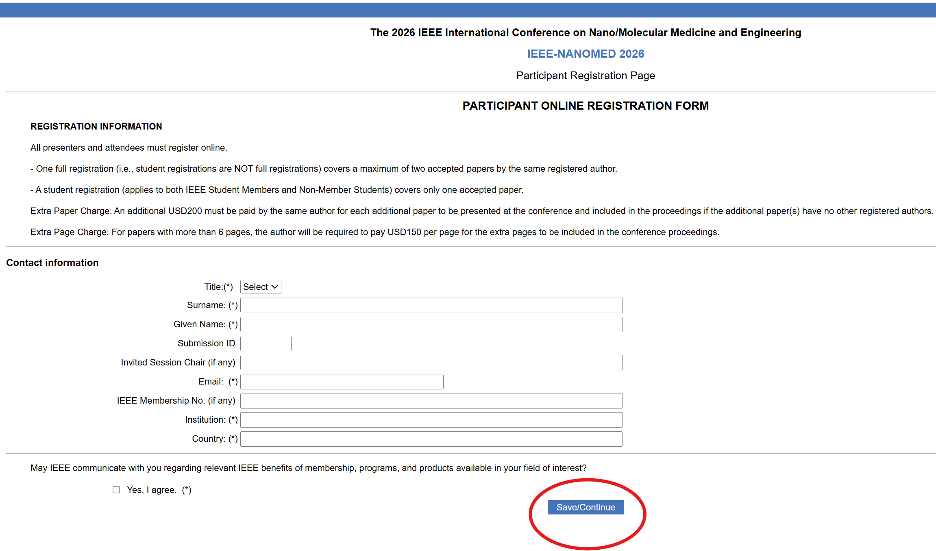
Step 2: Checkout

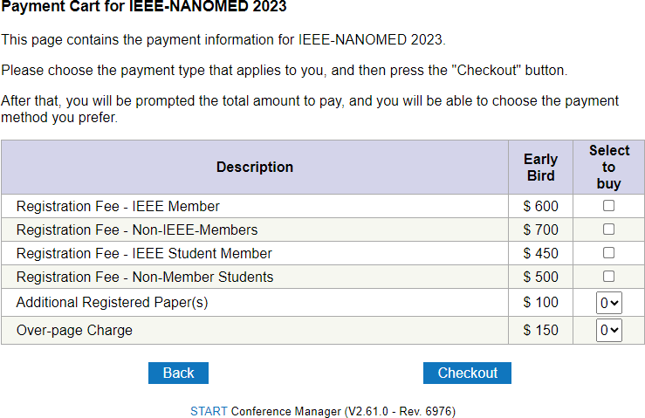
Step 3: Pay Now
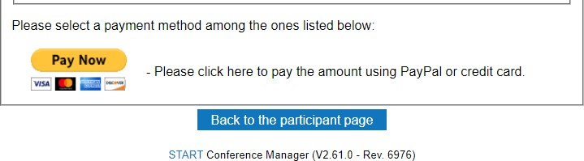
Step 4: Pay with Debit or Credit Card

